**IMPLEMENTATION OF AGGREGATE FUNCTIONS IN SQL**

CREATE TABLE STUDENT1 (

SROLL INT PRIMARY KEY,

SNAME VARCHAR(50),

PHYSICS INT,

CHEMISTRY INT,

MATHEMATICS INT

);

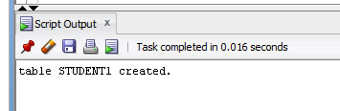

DESC STUDENT1;

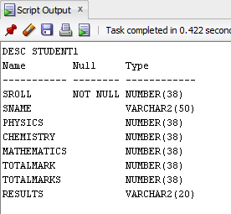

INSERT INTO STUDENT1 VALUES(01,'Harry',24,23,30);

INSERT INTO STUDENT1 VALUES(02,'Ron',10,24,25);

INSERT INTO STUDENT1 VALUES(03,'Karan',15,24,28);

INSERT INTO STUDENT1 VALUES(04,'Achi',19,20,19);

INSERT INTO STUDENT1 VALUES(05,'Peter',22,19,28);

INSERT INTO STUDENT1 VALUES(06,'Jimmy',21,20,25);

INSERT INTO STUDENT1 VALUES(07,'Taylor',24,24,29);

INSERT INTO STUDENT1 VALUES(08,'Ginny',20,24,23);

INSERT INTO STUDENT1 VALUES(09,'Abella',21,14,21);

INSERT INTO STUDENT1 VALUES(10,'William',23,22,29);

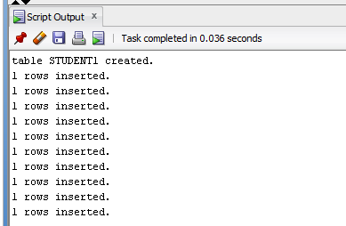

SELECT * FROM STUDENT1;

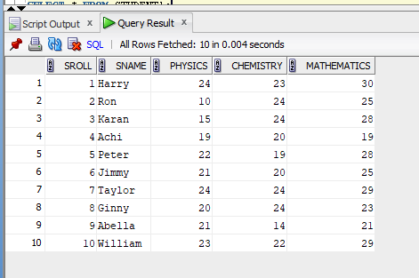

1. SELECT AVG(PHYSICS) AS PHYSICS_AVG FROM STUDENT1;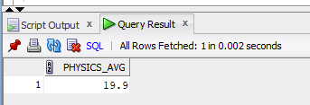
2. SELECT MAX(MATHEMATICS) AS HIGHEST_MARKS_MATHS FROM STUDENT1;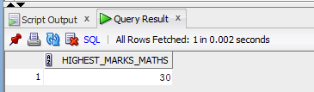
3. SELECT MIN(CHEMISTRY) AS LOWEST_MARKS_CHEMISTRY FROM STUDENT1;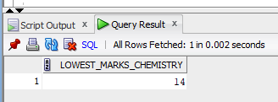
4. SELECT COUNT(*) AS PHYSICS_PASSED FROM STUDENT1 WHERE PHYSICS>=12;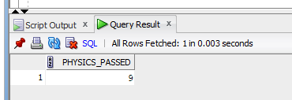
5. SELECT * FROM STUDENT1 WHERE PHYSICS>= 12 AND CHEMISTRY>= 12 AND MATHEMATICS>= 25;

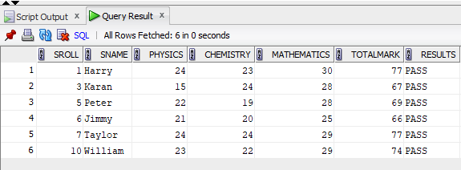

1. SELECT SNAME,PHYSICS,CHEMISTRY,MATHEMATICS,(PHYSICS+CHEMISTRY+MATHEMATICS) AS TOTALMARK,

CASE

WHEN PHYSICS >=12 AND CHEMISTRY >= 12 AND MATHEMATICS >= 25 THEN 'Pass'

ELSE 'Fail'

END AS RESULT,

RANK ( ) OVER(ORDER BY ( PHYSICS+CHEMISTRY+MATHEMATICS) DESC) AS RANK

FROM STUDENT1

ORDER BY RANK;

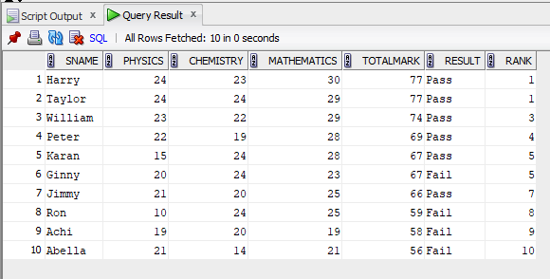

1. SELECT (COUNT(MATHEMATICS))/10*100 AS MATHS_PASS_PERCENTAGE FROM Student1 WHERE MATHEMATICS>24;

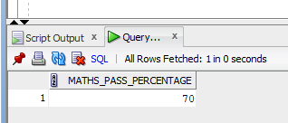

1. SELECT (COUNT(SNAME))/10*100 AS ALL_PASS FROM Student1 WHERE physics>11 AND chemistry > 11 AND mathematics >24;

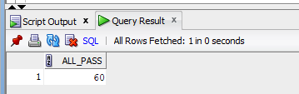

1. SELECT AVG(TOTALMARK) AS TOTALMARK_AVG FROM Student1;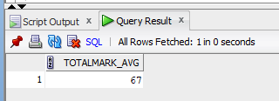
2. SELECT COUNT(Results) AS PASSED FROM Student1 WHERE Results='PASS';